**Project Report**

**on**

**Diabetes Prediction using Machine Learning**

**Submitted as partial fulfillment for the award of**

**BACHELOR OF TECHNOLOGY**

**DEGREE**

**Session 2022-23**

**in**

**Machine Learning**

**By**

**Subham Sinha**

**1900320100166**

**Suyash Pratap Singh**

**1900320100172**

**Shashank Pratap Singh**

**1900320100147**

**Under the guidance of**

**Ms. Shweta Roy (Professor)**

**ABES ENGINEERING COLLEGE, GHAZIABAD**

|  |  |  |
| --- | --- | --- |
| Description: C:\Users\es00952\Desktop\Logo.jpg | APJAK logo |  |

**AFFILIATED TO**

**DR. A.P.J. ABDUL KALAM TECHNICAL UNIVERSITY, U.P., LUCKNOW**

**(Formerly UPTU)**

**STUDENT’S DECLARATION**

**We** hereby declare that the work being presented in this report entitled ***“DIABETES PREDICTION USING MACHINE LEARNING”*** is an authentic record of ***our*** own work carried out under the supervision of Ms. “SHWETA ROY.

The matter embodied in this report has not been submitted by ***us*** for the award of any other degree.

**Signature of students(s) Date: 10/05/2023**

**Subham Sinha**

**Suyash Pratap Singh**

**Shashank Pratap Singh**

**Department:**

## This is to certify that the above statement made by the candidates is correct to the best of my knowledge.

## Signature of Supervisor Signature of Project Coordinator Signature of HOD

## Name: Ms. Shweta Roy Prof. (Dr.) Divya Mishra

## Designation: Professor HOD-CSE

## Department: Computer Science & Engineering Department

## 

**CERTIFICATE**

This is to certify that Project Report entitled “ **DIABETES PREDICTION USING MACHINE LEARNING** ” which is submitted by **Subham Sinha, Suyash Pratap Singh, Shashank Pratap Singh** in partial fulfillment of the requirement for the award of degree Bachelors of Technology in Department of Computer Science and Engineering of Dr. A.P.J. Abdul Kalam Technical University, formerly Uttar Pradesh Technical University is a record of the candidate’s own work carried out by them under my supervision. The plagiarism percentage evaluated for the content presented is 14 %.

The matter embodied in this Major Project Report is original and has not been submitted for the award of any other degree.

**Supervisor Signature**

**Name: Shweta Roy**

**Designation: Professor**

**Date: 10/05/2023**

ACKNOWLEDGEMENT

It gives us a great sense of pleasure to present the report of the B. Tech Project undertaken during B. Tech. Final Year. We owe a special debt of gratitude to Professor Ms. Shweta Roy, Department of Computer Science & Engineering, ABESEC, Ghaziabad for her constant support and guidance throughout the course of our work. Her sincerity, thoroughness and perseverance have been a constant source of inspiration for us. It is only her cognizant efforts that our endeavors have seen the light of day.

We also take the opportunity to acknowledge the contribution of Professor (Dr.) Divya Mishra, Head, Department of Computer Science & Engineering, ABESEC Ghaziabad for her full support and assistance during the development of the project.

We also do not like to miss the opportunity to acknowledge the contribution of all faculty members of the department for their kind assistance and cooperation during the development of our project. Last but not the least, we acknowledge our friends for their contribution in the completion of the project.

*Signature:  :*

*Name : Subham Sinha*

*Roll No.: 1900320100166*

*Date : 07/10/2022*

*Signature:*

*Name : Suyash Pratap Singh*

*Roll No.: 1900320100172*

*Date : 07/10/2022*

*Signature:*

*Name : Shashank Pratap Singh*

*Roll No.: 1900320100147*

*Date : 07/10/2022*

ABSTRACT

*Low insulin levels and high blood glucose levels in the body are the causes of diabetes. The symptoms of this raised blood sugar level include increased thirst, appetite, and frequency of urinating. Diabetes shouldn't be neglected since, if left untreated, it can have serious effects for a person, such as damage to the kidneys, heart, eyes, blood pressure, and other bodily organs. Diabetes may be controlled if it is discovered early.*

*However, diabetes makes this procedure inefficient. The most prevalent types of diabetes are type 1 and type 2, but there are other varieties as well, including gestational diabetes, which appears during pregnancy. For a higher degree of accuracy, we will use a variety of machine learning techniques to predict early onset diabetes in a human body or patient. Machine learning techniques build models using patient datasets to improve the accuracy of predictions. A recent branch of data science called "machine learning" studies how computers pick up knowledge via knowledge.*

*The goal of this effort is to create a system that can more accurately identify early diabetes in a patient by merging the findings of different machine learning approaches. K-Nearest Neighbor, Decision Tree, Random Forest, Support Vector Machine, and Logistic Regression are some of the methodologies employed. The model's and each method's accuracy are calculated. The diabetes prediction model with the highest accuracy is then chosen. Random forest algorithm has the maximum efficiency among all the machine learning algorithms on which the data has been tested.*

**TABLE OF CONTENTS** Page

DECLARATION ................................................................................................….. ii

CERTIFICATE……...........................................................................................….. iii

ACKNOWLEDGEMENTS ...............................................................................….. iv

ABSTRACT ........................................................................................................... v

LIST OF TABLES.................................................................................................. vii

LIST OF FIGURES................................................................................................ viii

LIST OF SYMBOLS .............................................................................................. ix

LIST OF ABBREVIATIONS ...........................................................................……. x

CHAPTER 1 ………………………………………………………………………………. 1

1.1. ..............................................................................................................…. 2

1.2. ..............................................................................................................…. 4

CHAPTER 2 ……………………………. .......................................................………. 6

CHAPTER 3 ……………………………........................................................………. 7

3.1. .............................................................................................................…… 7

3.2. .............................................................................................................…… 11

CHAPTER 4 ……………………. ....................................................................…… . 19

4.1. ……………………………………………………………………………………. 19

4.2……………………………………………………………………………………… 22

4.3. ……………………………………………………………………………………. 23

CHAPTER 5 (CONCLUSION) .. ....................................................................…….. 37

APPENDIX A .......................................................................................................…. 38

REFERENCES... ................................................................................................………..…39

**LIST OF TABLES**

|  |  |  |
| --- | --- | --- |
| **S.No** | **Table Name** | **Page No** |
| **1.** | Working on automatic non-invasive diabetes screening utilizing HRV. | **15** |
| **2.** | Dataset Description. | **20** |
| **3.** | Result Table | **47** |

**LIST OF FIGURES**

|  |  |  |
| --- | --- | --- |
| **S.No** | **Figure Name** | **Page No** |
| **1.** | System Design. | **17** |
| **2.** | Data Flow Diagram | **17** |
| **3.** | Box and Whiskers Plot | **18** |
| **4.** | Corelation Matrix | **18** |
| **5.** | Histogram | **19** |
| **6.** | Support Vector Machine (SVM) | **22** |
| **7.** | 1. Nearest Neighbour (KNN) | **23** |
| **8.** | Decision Tree | **24** |
| **9.** | Logistic Regression | **25** |
| **10.** | Random Forest | **26** |
| **11.** | Gradient Boosting | **27** |
| **12.** | Snapshot of Interfaces | **33-37** |
| **13.** | Test Cases | **38-42** |
| **14.** | Information of the dataset | **43** |
| **15.** | Showing the count of NAN | **43** |
| **16.** | Data Visualization Histogram | **44** |
| **17.** | Diabetic and Non - Diabetic count | **44** |
| **18.** | Classification report and confusion matrix | **45-46** |

**LIST OF SYMBOLS**

[x] Integer value of x.

≠ Not Equal

∈ Belongs to

**LIST OF ABBREVIATIONS**

SVM Support Vector Machine

KNN K - Nearest Neighbour

ML Machine Learning

CNN Convolutional Neural Network

HRV Heart Rate Variability

WHO World Health Organization

UCI Unique Client Identifier

**CHAPTER 1**

**INTRODUCTION**

Medical experts and other healthcare providers typically refer to diabetes, a chronic illness, as diabetes mellitus. Insufficient insulin synthesis, inappropriate insulin cell response, or a combination of the two can all lead to high blood sugar levels, which is what this word refers to as a set of metabolic illnesses. As a result, the level of glucose in the blood will increase. Although certain cases of diabetes are difficult to classify, type 1 and type 2 cases of the disease may be loosely classified into two groups. If diabetes is not treated, it causes several negative side effects.

As a result, not only does it harm individuals, but it also causes heart failure, kidney difficulties, and blindness. Due to inadequate pancreatic insulin synthesis or a body's inability to use the insulin that is produced, diabetes develops when blood glucose levels rise. Elevated amounts of glucose (sugar) in the blood and urine are signs of diabetes mellitus.

**TypesaofaDiabetes**

**Typea1 :** Type 1 diabetes patients have a weakened immune system and decreased insulin synthesis in their cells. There are presently no proven preventative measures or therapies for type 1 diabetes, nor is it known with certainty what the causes are.

**Typea2 :** Either inadequate insulin production by cells or incorrect insulin usage by the body are characteristics of diabetes. 90% of people with diabetes have this kind, making it the most common type. Genetics and dietary habits both have a role in its occurrence.

**GestationalaDiabetes:** High fasting blood sugar levels in pregnant women are a risk factor for gestational diabetes. In two-thirds of the cases, it will return during subsequent pregnancies. There is a considerable chance that type 1 or type 2 diabetes will manifest after a pregnancy in which gestational diabetes was present.

SymptomsaofaDiabetes.

• FrequentlyaUrination • Increasedathirst • Tired /aSleepiness • Weightaloss

• Blurredavision • Confusion andadifficultyaconcentrating • MoodaSwings

**CausesaofaDiabetes**

Genetics is primarily to blame for diabetes. It is caused by at least two chromosome 6 genes that are faulty and change how the body responds to certain antigens. Viral infection has the ability to influenceathe development of type 1aand type 2adiabetes. According to studies, carrying viruses such the CMV, mumps, rubella, or hepatitis B virus increases the likelihood of acquiring diabetes.

Diabetes is now one of the leading causes of illness and death in the vast majority of countries. This number is expected to approach 642 million by 2040, according to the International Diabetes Federation; as a result, early screening and identification of diabetes patients is essential for early detection and effective treatment. Due to the nonlinear, atypical, correlation-structured, andccomplex character of the majority of medical data, analysing diabetic data can be difficult.

**1.1. Problem Introduction**

**1.1.1. Motivation**

By 2020, 463 million people globally, including 88 million in Southeast Asia, are expected to get diabetes, according to the International Diabetes Federation (IDF).

These 88 million individuals include 77 million Indians. According to the IDF, 8.9% of people have diabetes. In terms of the prevalence of type 1 diabetes among children, India is second only to the United States, according to IDF estimates. In the SEA region, type 1 diabetes in children is also more common there than everywhere else. Diabetes is said to be the cause of 2% of all fatalities in India, according to the WHO.

India now has 65 million diabetics, up from 26 million in 1990. The prevalence was determined to be 11.8% among those over 50,aaccording to the Ministry of Health and Family Welfare's report on the 2019 National Diabetes and Diabetic Retinopathy Survey. According to the DHS study,a6.5% of those under 50 have diabetes, and 5.7% have prediabetes.aBoth the male (12%) and female (11.7%) groupings were equally frequent.

It wasahigher inacities. Testing revealed that the sight-threatening condition diabetic retinopathy was present in 16.9% of diabetics up to the age of 50. According to the survey, people aged 60 to 69, 70 to 79, and those beyond the age of 80 were most likely to have diabetic retinopathy (18.6%, 18.3%, and 18.4%, respectively). For people aged 50 to 59, the incidence was 14.3% lower.

In India, type 2 diabetes patients fall into four subgroups or clusters, of which two are peculiar to that nation. These categories may face varying levels of problem risk and require different treatments.

Women are the ones who are most affected, howeverachildren and young people account for the bulk of instances that have been reported. We have decided to work on a machine learning-based diabetes detection tool in view of these worrying figures.

**1.1.2. Project Objective**

The objective is to transform the desired outcome into a measurable and manageable goal.

Find answers by coming up withamachine learning concepts (how to address the issue and accomplish the desired result). First comes divergent reasoning, then follows convergent reasoning.

The main goal is to develop and test manyamachine learning models, assess their precision, and choose the best and most precise one among them to recognize diabetes in a person based on particular traits and attributes.

**1.1.3. Scope of the Project**

The process of scoping involves detailing a project and choosing the resources that will be utilized to finish it. There is more to planning than just that, though. Additionally, you must formulate the right queries, determine the objectives of your business, and then match those objectives with machinealearning solutions. The first and generally regarded as the most important stage of a machine learningaproject's overall process isa scoping.

Around 350 million people will have diabetes globally by 2030, and 642 million will by 2040, predicts the World Health Organization (WHO).

In order to minimize the diabetes pandemic that has befallen humanity, the scope involves creating machine learning models and testing them to see which ones are the most accurate to utilize in real-world circumstances.

**1.2. Related Previous Work**

A great deal of research has been conducted on the non-invasive automated detection of diabetes usingamachine learning approaches. Utilizing the procedures of feature extraction, feature selection, and classification, machine learning was put into practise. There were various studies that differed in the classifiers used and the extracted characteristics. Additionally, it was shown that standard machine learning algorithms performed poorly on important AI tasks like speech recognition and object identification, mostly due to the amount of the data they had to handle.

The inadequacies of machine learning encouraged the development of deep learning research. Deep learning has further uses in the medical field. A considerable number of new studies have been published recently, particularly in the field of healthcarea anomaly detection. Deep learning methods were used to make the diabetes diagnosis, and the accuracy level that resulted was about equivalent to the highest level of automated diabetes detection accuracy at the time. In the aforementioned study, we classified diabetes with a 95.7% accuracy rate. The most significant studies on the automated, noninvasive diagnosis of diabetes using HRV are compiled in Table 1.

Table 1: Works on the automated non-invasive detection of diabetes using HRV

| **Methods** | **Accuracy obtained (in %)** |
| --- | --- |
| Nonlinear | 86.0 |
| Higher order spectrum | 90.5 |
| Higher order spectrum | 79.93 |
| Nonlinear | 90.0 |
| Discrete wavelet transform | 92.02 |
| Empirical mode decomposition | 95.63 |
| Deep learning (CNN - LSTM) | 95.1 |
| Deep learning | 95.7 |

**CHAPTER 2**

**LITERATURE SURVEY**

1. Vijiya Kumar [1] To more precisely predict a patient's risk of acquiring diabetes early on, K. developed a machine learning system that makes use of the Random Forest algorithm. The results demonstrated the prediction system's ability to accurately, quickly, and most importantly, efficiently anticipate the diabetes condition. Following the usage of five commonly utilised classifiers for the ensembles, the findings were integrated using a meta-classifier. The outcomes are displayed and contrasted with findings from earlier studies that made use of the same dataset. It has been demonstrated that the proposed method can more precisely predict when diabetes would begin.

Aishwaryaa[2] attempts to create techniques toadiagnose diabetes by researching and analysing the patterns that appear in the dataathrough classification analysis using Decision Tree and Naive Bayes algorithms.. The study's goal is to develop a faster and more accurate means of disease diagnosis, which will aid in patients' quick treatment. Using a 70:30 split, the PIMA dataset, and a cross validation procedure, the study revealed that the J48 method achieves an accuracy rate of 74.8%, while the naive Bayes method achieves an accuracy rate of 79.5%.

Leeeet al. [3] Focusaon using the CART decision tree algorithmaon the diabetes dataset after the data has been processed using the resample filter. The author emphasises the need of fixing the class imbalance problem before using any technique to increase accuracyarates. Class imbalance is more common in datasets with dichotomous values, which demonstrate the existence of a class variable with two alternative outcomes. If this imbalance is identified earlier during the data pre-processing stage, the prediction model's accuracy will increase.

**CHAPTER 3**

**SYSTEM DESIGN AND METHODOLOGY**

* 1. **System Design**

**3.1.1 System Architecture**

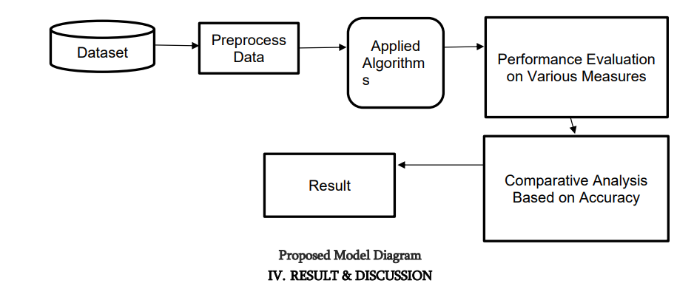

**3.1.2** **Data Flow Diagram**

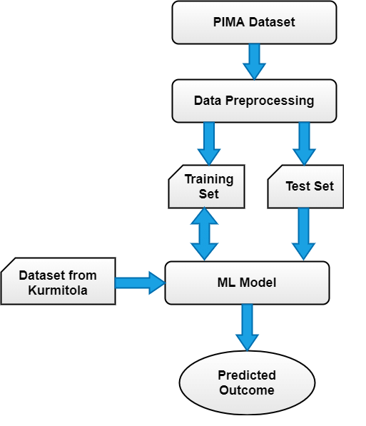

**3.1.3. Box and Whiskers Plot**

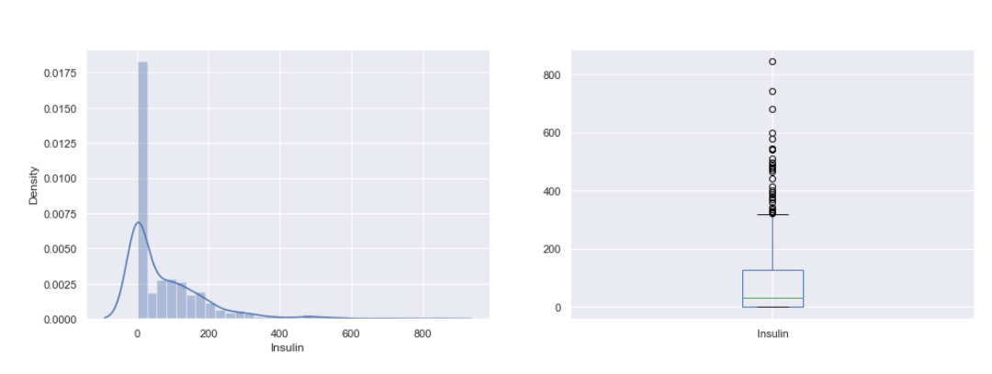

**3.1.4. Corelation Matrix**

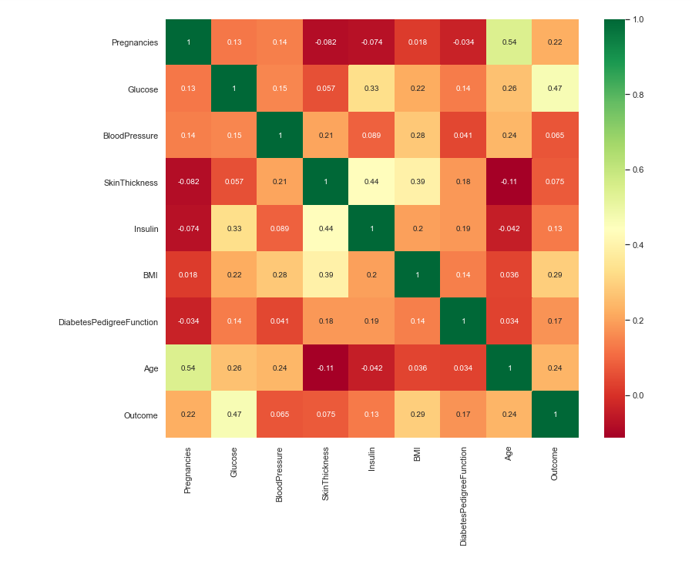

**3.1.5. Histogram**

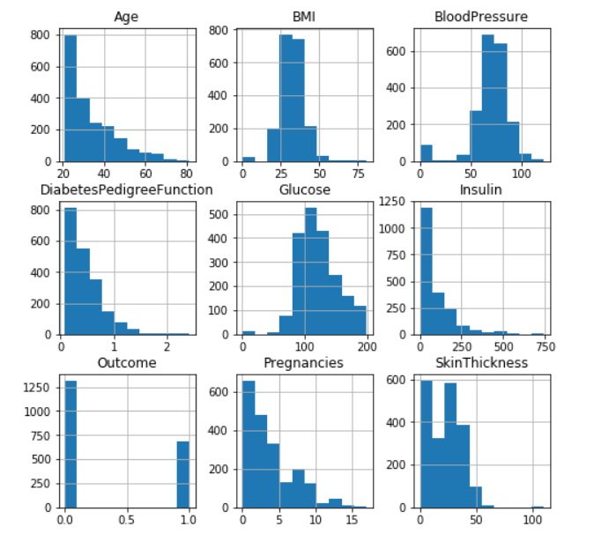

**Dataset Description**

The data was discovered in the UCI Pima Indian Diabetes Dataset repository. There is a lot of data in the collection regarding 768 patients.

The ninth characteristic foraeach data point is the class variable. This class variable indicates if the result is positive or negative for diabetes by showing the result for diabetics (0 or 1).

Distributionaof Diabetic Patients: Despite the fact that we developed a model to predict diabetes, the dataset had 268 classes that had the label "1 indicates positive" and 268 classes that had the label " 2 means negative."

Table 2 : Descriptionaof the Dataset

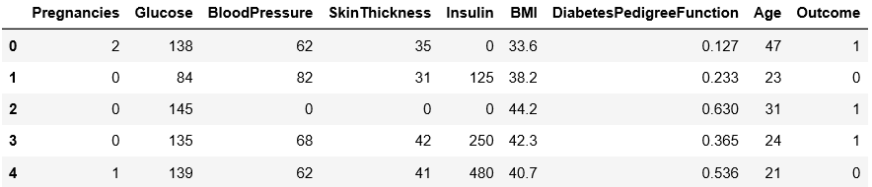

* There are 2000 data points in the diabetes data collection, each with nine attributes..
* We will forecast a characteristic called "Outcome," where 0 indicates no diabetes and 1 indicates diabetes.
  1. **Algorithm(s)**

Apply machine learning: When the data is ready, the machine learning technique is used. To forecast diabetes, we employ a variety of ensemble and classification algorithms. the processes used to analyse the diabetes dataset among Pima Indians. The main goal is to use ML techniques to analyse the effectiveness of various approaches, evaluate their accuracy, and identify the critical variable that influences prediction.

The Techniques are follows -

1. **SupportaVector Machine** - SVM stands for supportavector machine, which is a method of supervised machine learning. The most used classification approach is SVM. SVM creates a hyperplane that divides two classes. It can result in a hyperplane or collection of hyperplanes in high-dimensional space. Regression or classification may both be performed using this hyperplane. SVM can distinguish between samples in particular classesaand categorise objects for which no supporting data is available. A hyperplane is used to locate the nearest training site for each class for separation.

Algorithm-

* Choose.the hyperplane that best divides the class.
* To determine the best hyperplane, you must compute the Margin, whichais the distance between the planes and the data.
* Likelihood of miscarriage is higher and vice versa depending on how far the classes are from one another. As a result, we must
* Choose the class with the highest margin. Margin equals the distance between the positive and negative points.

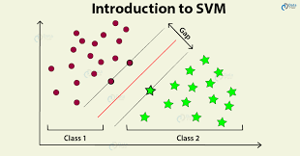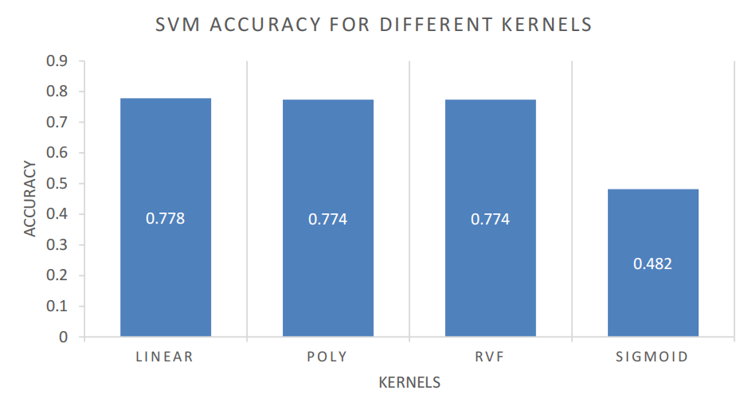

1. **K - NearestaNeighbor-**  KNN is a supervisedamachine learning method that is distinct from others. KNN aids in the resolution ofaclassification and regression difficulties. KNN is a slackaprediction approach. According to KNN, similar objects should be found near to one another. Close proximity between similar data points is commonly seen. KNN provides assistance in categorizing new work using a similarity metric. Every record is collected and categorized using the KNN algorithm according to how similar they are. The distance between the places is calculated using a tree-like structure. To predict a new data point, the approach determines the closest training data points. K stands for "number of near neighbours," isaalways a positive integer in this context. A class value is selected for neighbours from a list of class values.

Algorithm-

* Check out the Pima Indian Diabetes data collection, an example dataset with rowsaand columns.
* Think of a test dataset that has characteristics and rows.
* Determine the Euclidean distance byausing the formula.
* The number of closest neighbours, K, should then be chosen at random.
* Then, using these minimal distances and Euclidean distance, each is calculated to the nth column.
* Discover the identical output values.
* The patient is diabetic if the levels are the same;aotherwise, the patient is not.

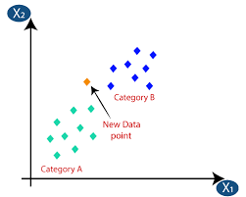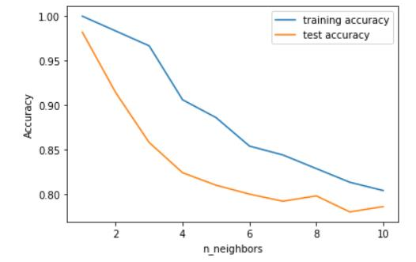

1. **Decision Tree** - A significant categorising tool is the decisionatree. It is a method of supervisedalearning. When the response variable is categorical, a decision tree is utilised. A decision tree is a tree-like architecture that selects categorisation depending on input characteristics. Input variables might be text, discrete, continuous, or graph.

Steps for DecisionaTree Algorithm-

* Buildaa tree using nodes as inputafeatures.
* Choose the feature withathe best information gain to forecast the outputafrom the input feature.
* For each characteristicain each tree node, the greatest informationagain is determined.
* Repeat step 2 to create a sub-tree utilisingathe feature that was not utilised inathe previous node.

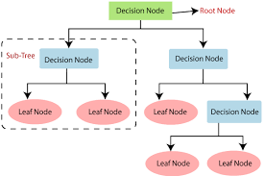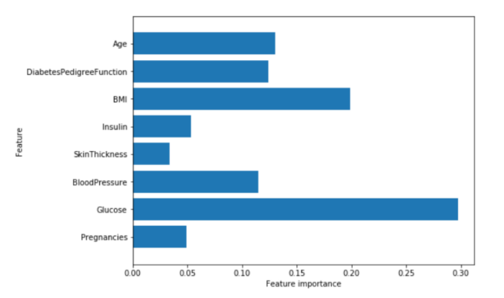

1. **Logistic Regression** -Logistic regression is yet another classification approach used in supervised learning. A binary response's propensity to be influenced by one or more predictors is assessed using this method. Discrete and continuous ones are both feasible. We utilise logistic regression to categorise or divide particular data points into groups.

Only the numbers 0 and 1 are used to classify the data in binary form, indicating whether or not a patient has diabetes.Logistic regression's main goal is to get the optimal fit,awhich best reflects the connection between the target and predictor variables. On top of the model for linear regression, logistic regression is constructed. To forecast the probability of the positiveaand negativeaclasses, the logistic regression model uses the sigmoid function.

Pa= 1/1+e -a(a+bx) Sigmoid function P denotes probability, a andab denotes Model parameters.

**Ensemblinga**- A machinealearning strategy is being developed. Numerous learning algorithms are blended in an ensemble to accomplish a certain goal. It is utilised because it predicts more accurately than any other model. Noise bias and variation are the primary drivers of inaccuracy, and ensemble techniques assist in minimising or reducing these errors. Two popular ensemble algorithms include voting, averaging, ada-boosting, bagging, and gradient boosting. In this work, we employed the Gradient Boosting Ensemble and Bagging (Random forest) approaches to detect diabetes.

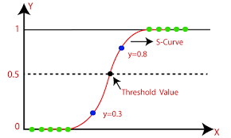

1. **RandomaForest** - It is an ensemble learningaapproach that is used in classification and regression applications. It is more accurate than previous models. This method can easily handle large datasets. Leo Bremen created Random Forest. It is a well-liked technique for group learning. By lowering variation, Random Forest enhances Decision Tree performance. The class that reflects the average of all classes, classifications, or average predictions (regressions) of all trees is formed after a large number of decision trees have been built during training.

Algorithm-

* Picking the R features where R>M from the total set of features is the first step.
* The node utilising the optimal split pointaamong the R characteristics.
* Using the best split, divide theanode into sub nodes.
* Repeatasteps a through c until the l th node is reached..

Repetition of steps a through d n times produced the n trees that made up the forest.

The Gin-IndexaCost Function is used by the random forest to determine the best split and is made available via:

Options are thought about, resultsaare projected using the bases of each decision tree that was produced at random, and the projected outcomes are stored at intervals around the desired location in the first step. Votes should be counted for each projected goal, and the projected goal with the mostasupport should be used as the result of the final random forest technique prediction. For a number of applications, Random Forest provides a wide range of techniques that deliver precise forecasts.

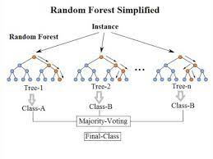

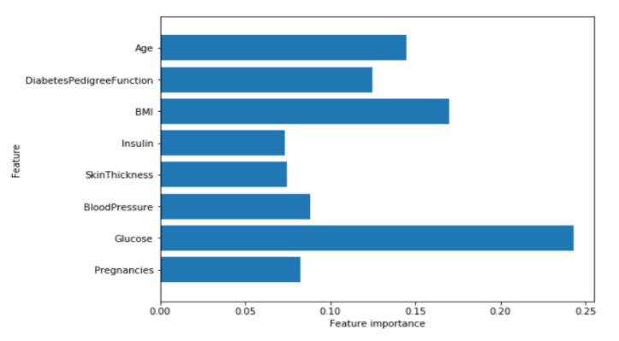

1. **GradientaBoosting** – The most effective ensemble method foraprediction and classification is gradient boosting.. Weak learners are combined to produce effective learning models for prediction. It is decided to employ the decision tree model. It is a popular and commonly used method for categorising huge, complex data sets. Gradient boosting models improve with iteration.

Algorithm-

* Considerathe following sample of target values: P.
* Calculateathe target value error.
* To decrease mistake M, update and change the weights.
* P[x] = aalpha M[x] + p[x]
* The loss function Faanalyses and calculates model learners.
* Repeat steps untiladesired and target result P is obtained..

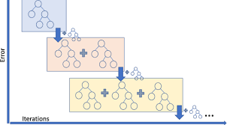

1. ****XGBoost -** It** is an optimized distributed gradient boosting library designed for efficient and scalable training of machine learning models. It is an ensemble learning method that combines the predictions of multiple weak models to produce a stronger prediction. XGBoost stands for “Extreme Gradient Boosting” and it has become one of the most popular and widely used machine learning algorithms due to its ability to handle large datasets and its ability to achieve state-of-the-art performance in many machine learning tasks such as classification and regression.

Algorithm-

## Make an Initial Prediction and Calculate Residuals

## Build an XGBoost Tree

## Prune the Tree

## Calculate the Output Values of Leaves

## Make New Predictions

## Calculate Residuals Using the New Predictions

## Repeat Steps 2–6

**CHAPTER 4**

# IMPLEMENTATION AND RESULTS

**4.1. Software and Hardware Requirements**

The major software and hardware requirements include :

**4.1.1 aPython**

A high-level, all-purpose programming languageais Python. Code readability is prioritised in its design philosophy, which typically employs indentation.

Both dynamic typing and garbage collection are supported by Python. Procedural, structured, object-oriented, and functional programming are just a few of the programming paradigms that it supportsa(especially this). This language's vast standard library has given it the nickname "batteries included."

Python was developed by Guido van Rossum in the late 1980s to replace the ABC programming language. Python 0.9.0 was made public in 1991. New features including list comprehensions,areference counting, cycle-detecting garbage collection, and support for Unicode were included in Python 2.0awhen it was released in 2000. 2008 saw the release of Python 3.0, a substantial change that wasanot entirely backwards compatible with earlier iterations. 2020 saw the end of Python 2 with version 2.7.18. Programming language Python routinelyaranks among the most well-liked ones.

**4.1.2 NumPy**

NumPy is a Python open source project that aims to make numerical computation easier. The Numeric and Numarray libraries' initial work served as the foundation for its creation in 2005. Free, fully open source, and in line with the permissive provisions of the modified BSD licence, NumPy will always be made available.

According to the NumPy and larger science Python communities, NumPy is maintained publicly on GitHub. Please see our Governance Document for more details on our governance strategy.

**4.1.3 Pandas**

Pandas is a collection of data analysis and manipulation tools made especially for the Python programming language. It provides detailed instructions for utilising mathematical tables and time seriesadata. It is free software that is released in accordance with the license's three clauses.

An econometrics term for data sets that include observations for the same people over several time periods is panel data. The name of Python data analysis is punny. In his time from 2007 to 2010 as a researcher at AQRaCapital, Wes McKinney started developing the pandas that would later become well-known.

**4.1.4 Matplot Lib**

Python's NumPy extension for numerical mathematics, along with Matplotlib, are graphing libraries. It provides an object-oriented APIafor adding charts to applications that make use of a general-purpose GUI toolkit like Tkinter, wxPython, Qt, or GTK. The state machine-based procedural "pylab" interface, designed to closely resemble the MATLAB interface, should not be used (similar to OpenGL).aIn SciPy, Matplotlib is utilised.

Matplotlib is ascribed to its creator, John D. Hunter. Since then, a healthy development community has developed around it, and it is presently available under a BSD-like licence. Michael Droettboom and Thomas Caswell were both suggested as matplotlib's primary developers before John Hunter passed away in August 2012. The Matplotlib project receives financial support from NumFOCUS.

Python 2.7 to 3.10 are compatible with Matplotlib 2.0.x. Python 3 was initially supported by Matplotlib 1.2, whereas Python 2.6 was last supported by Matplotlib 1.4. By committing to discontinue Python 2 support after 2020, Matplotlib made a commitment to the Python 3 Statement.

**4.1.5 Seaborn**

For Python and its NumPy extension for numerical mathematics, Matplotlib is a graphing library. It provides an object-oriented API for adding charts to software applications that make use of a general-purpose GUI toolkit like Tkinter, wxPython, Qt, or GTK. The procedural "pylab" interface, which is built on a state machine and was designed to closely resemble the MATLAB interface, should not be used. SciPy makes use of Matplotlib.

Matplotlib is ascribed to its creator, John D. Hunter. Since then, a healthy development community has developed around it, and it is presently available under a BSD-like licence. Michael Droettboom and Thomas Caswell were both suggested as matplotlib's lead developers prior to John Hunter's dying in August 2012. The Matplotlib project receives financial support from NumFOCUS.

Python 2.7 to 3.10 are compatible with Matplotlib 2.0.x. Python 3 was initially supported by Matplotlib 1.2, whereas Python 2.6 was last supported by Matplotlib 1.4. By pledging to discontinue support for Python 2 after 2020, Matplotlib made a commitment to the Python 3 Statement.

**4.1.6 Pimas Indian database**

This dataset was originally stored by the National Institute of Diabetes and Digestive and Kidney Diseases. Based on key diagnosticaindications that are available in the data, the dataset attempts to diagnose diabetes. Based on a number of factors, these examples were picked from a largeradatabase. Particularly, Pima Indian womenawho are at least 21 years old make up the majority of the clinic's clientele.

**4.2. MODEL BUILDING**

The stage that involves creating a model for predicting diabetes is the most crucial. This took use of the previously stated machine learning algorithms for diabetes prediction.The proposedamethodology's process-

Step 1: Import the diabetic dataset alongawith the necessary libraries.

Step 2: To fill in any gaps, Pre-process the data.

Step 3: Divide the dataset in half, 80% for training and 20% for testing.

Step 4: Choose from the following machine learning methods: K-Nearest Neighbor, Support Vector Machine, Gradient Boosting, Logistic Regression, Random Forest, and Decision Tree.

Step 5: For the aforementioned machine learning technique, create the classifier model based on the training set.

Step 6: To assess the Classifier model for the previously described machine learning technique, use a test set.

Step 7: Compare the experimental performance outcomes of each classifier.

Step 8: After analysing various metrics, select the best performing algorithm.

**4.3. Implementation Details**

**4.3.1. Snapshot of Interfaces**

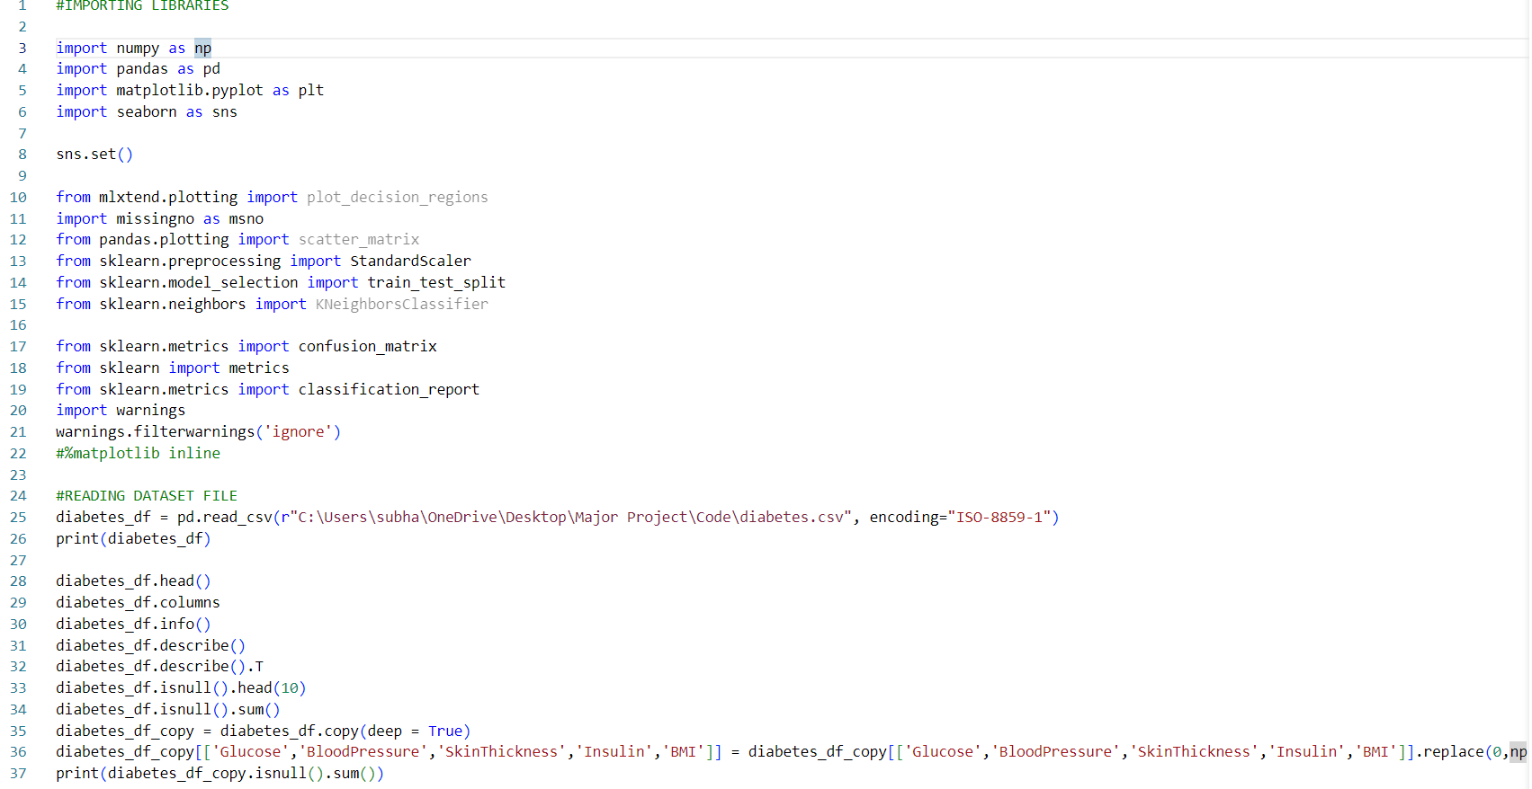

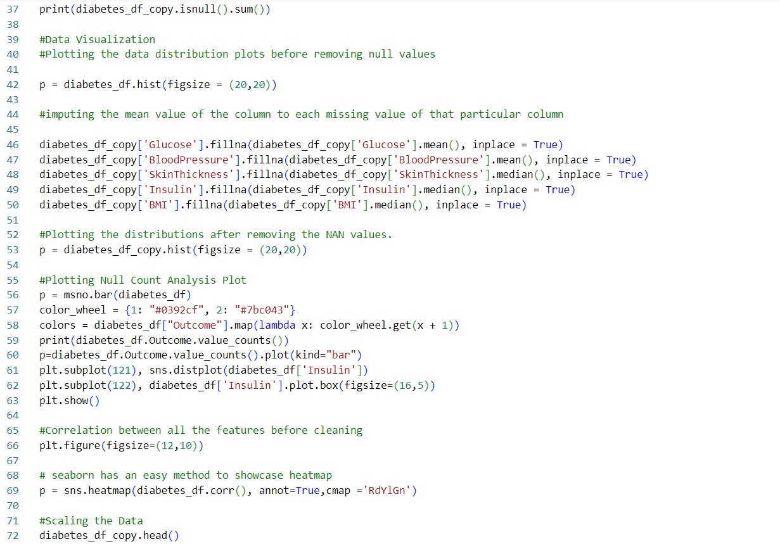

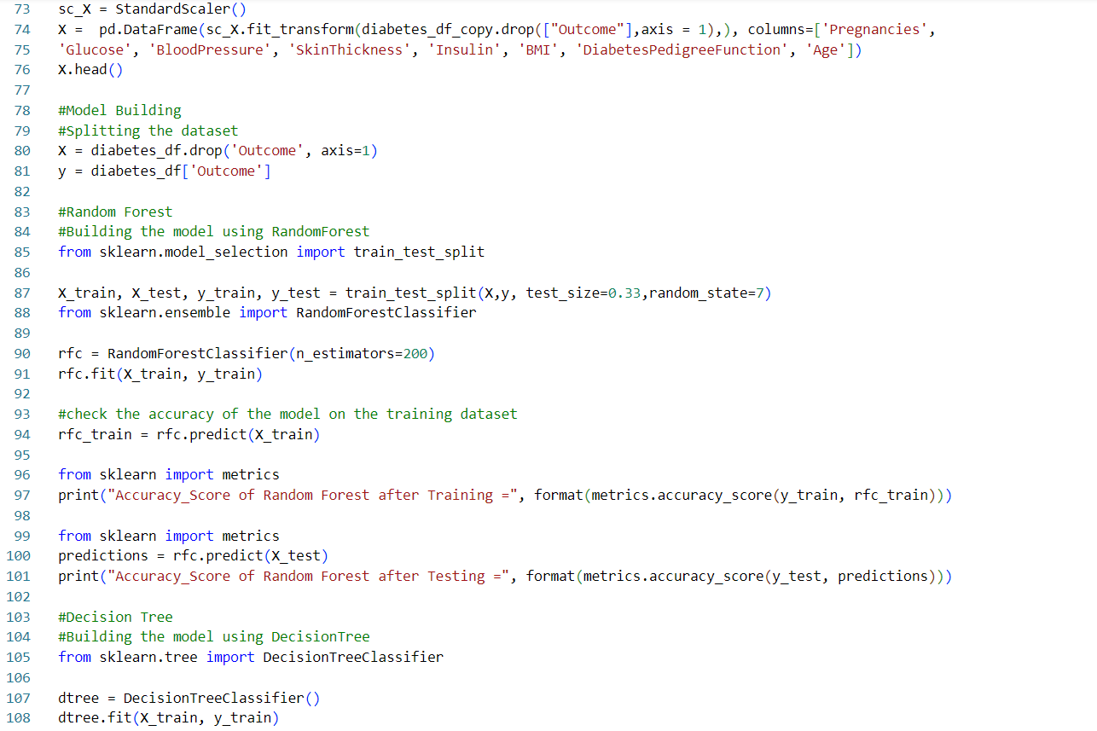

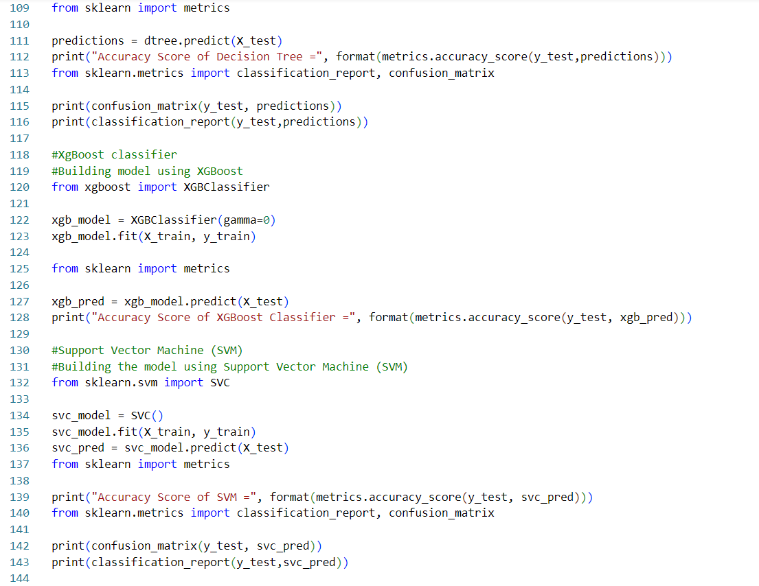

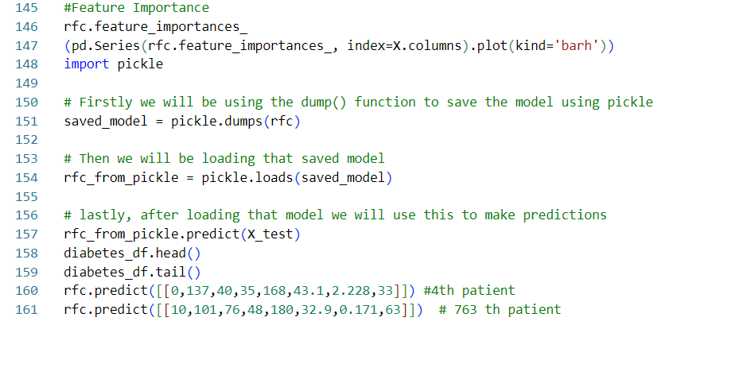

**4.3.2. Test Cases**

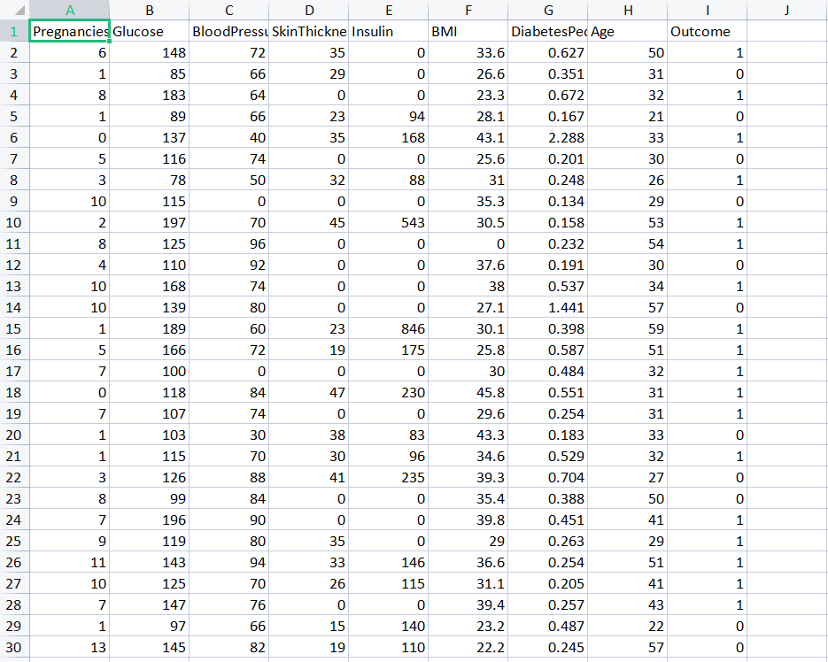

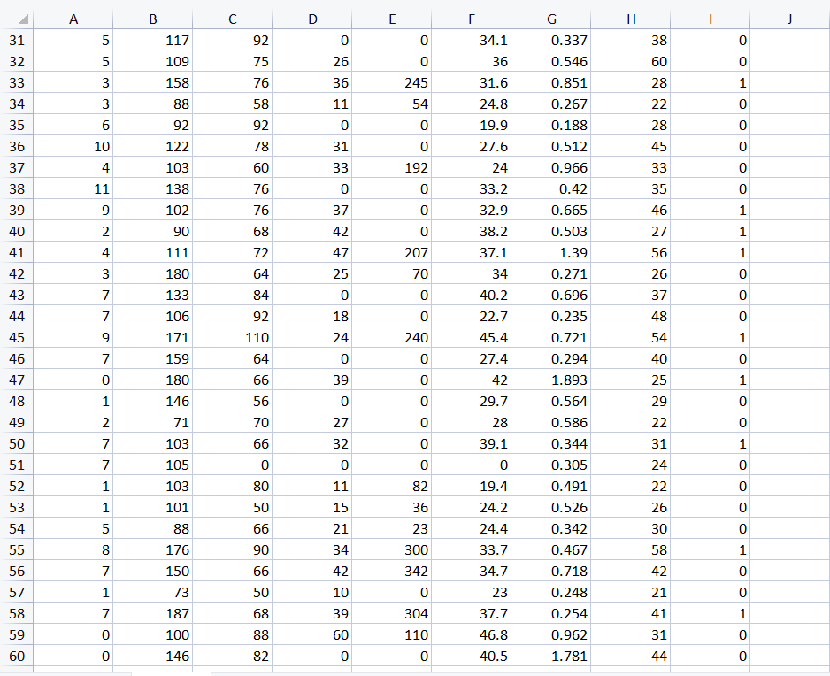

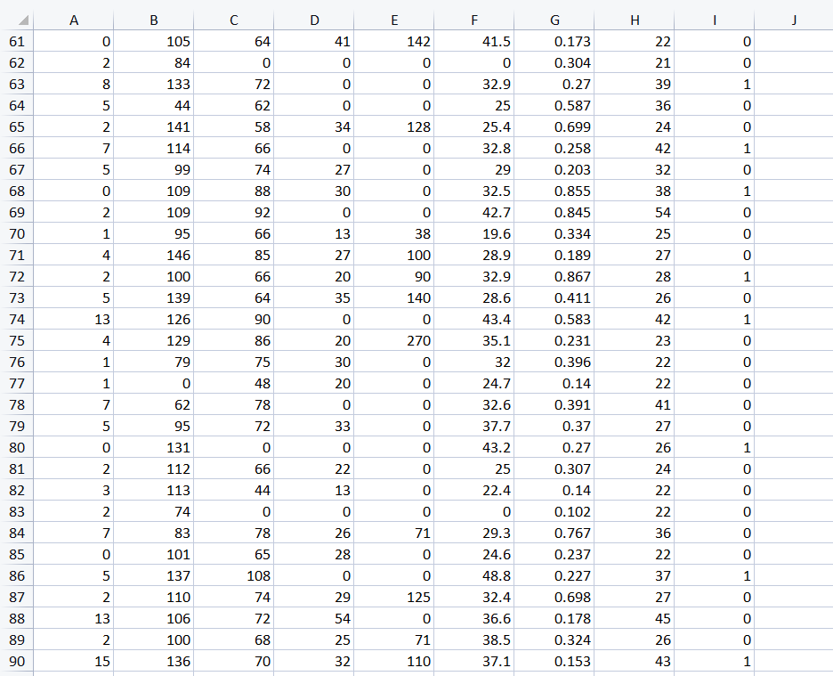

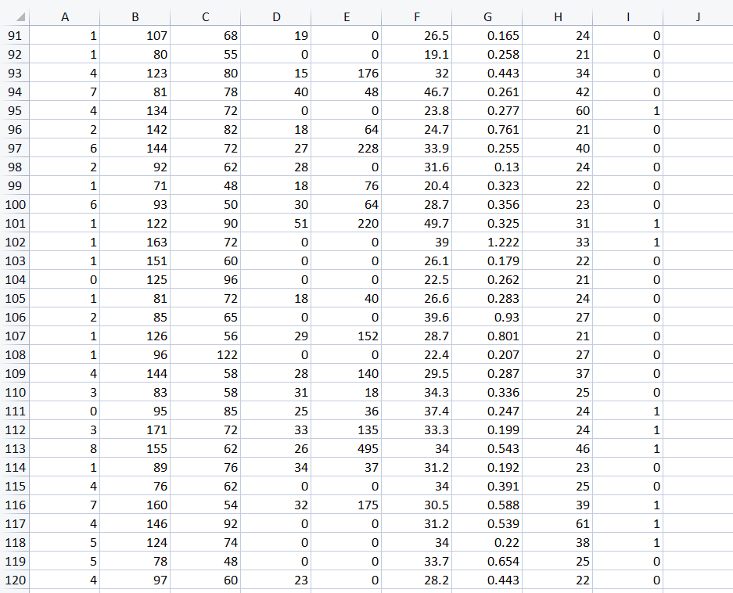

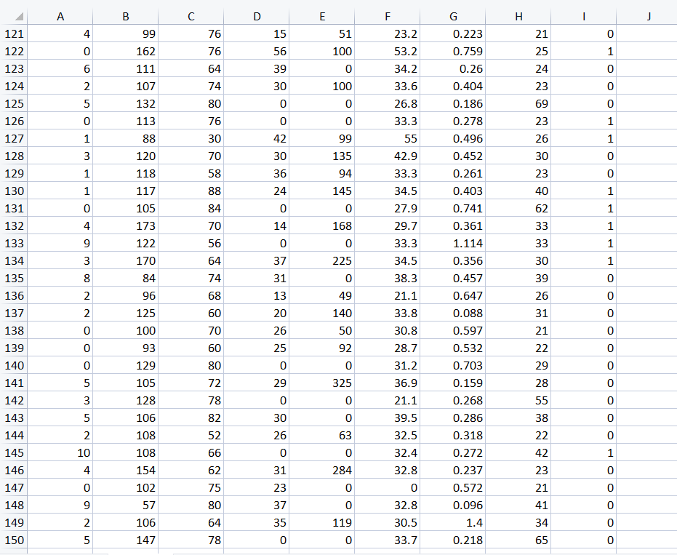

**4.3.3. Results**

**4.3.3.1. Information of the dataset**

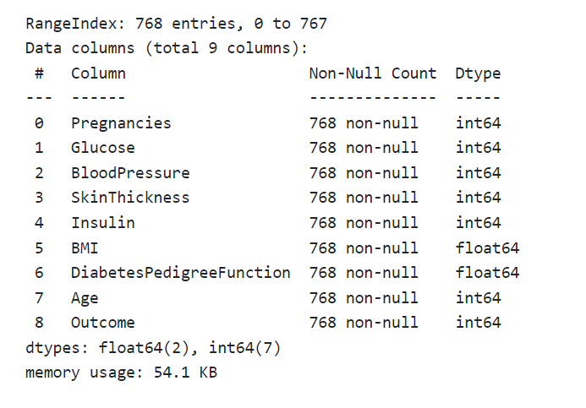

**4.3.3.2. Showing the count of NAN**

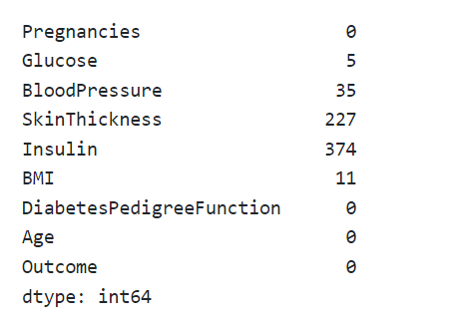

**4.3.3.3. Data Visualization Histogram**

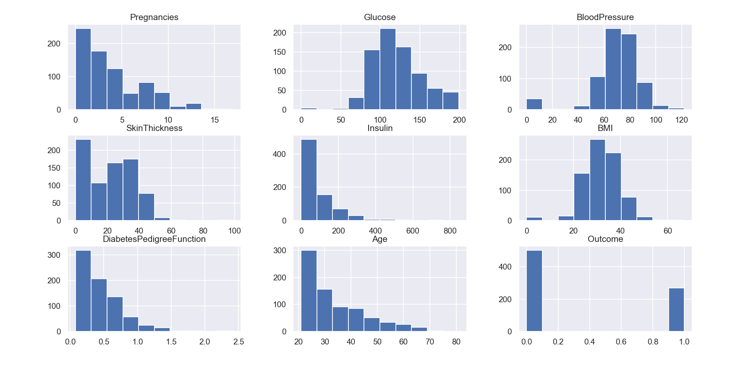

**4.3.3.4. Diabetic and Non - Diabetic count**

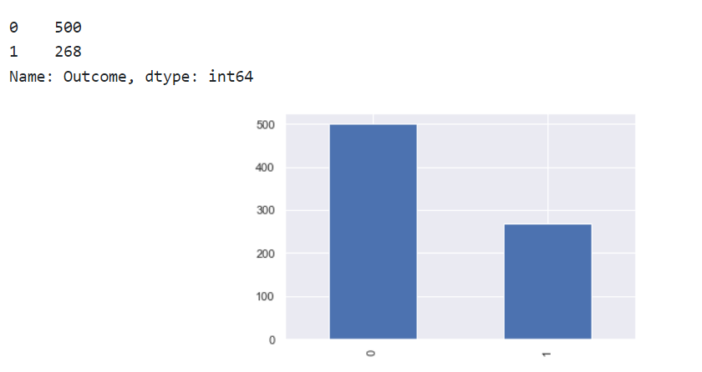

**4.3.3.5. Classification report and confusion matrix of random forest model**

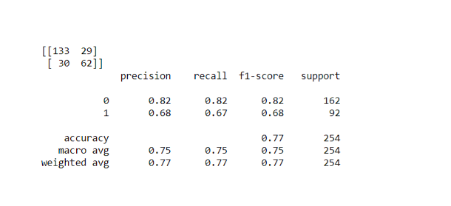

**4.3.3.6. Classification report and confusion matrix of the decision tree model**

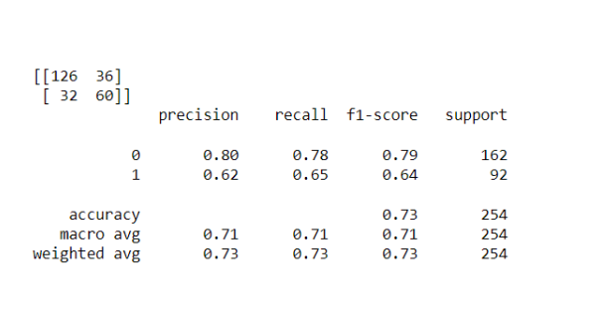

**4.3.3.7. Classification report and confusion matrix of the XGBoost classifier**

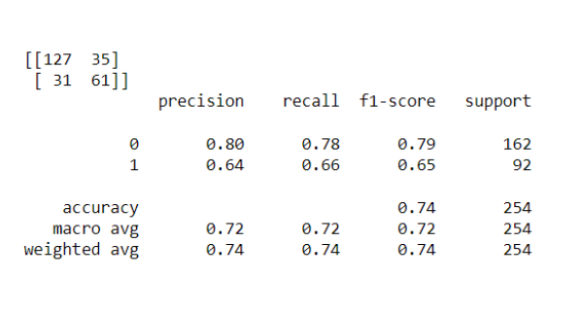

**4.3.3.8. Classification report and confusion matrix of the SVM classifier**

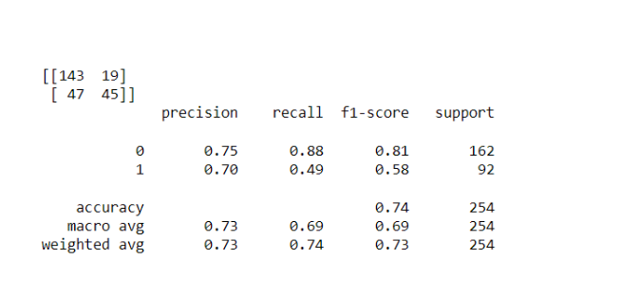

**CHAPTER 5**

# CONCLUSION

Theaearly diagnosis of diabetes is oneaof the most significant medicalaissues today. This strategy consciously works to create a diabetes prediction system. Sixamachine learning categorization techniques are looked into and assessed in this study based on a number of different factors. Experiments are being carried out on the Pima Indian database.

**Result:**

|  |  |
| --- | --- |
| **Algorithms** | **Accuracy ( in %)** |
| **SVM** | **0.7480314960629921** |
| **Decision Tree** | **0.7165354330708661** |
| **Random Forest** | **0.7677165354330708** |
| **XGBoost Classifier** | **0.7401574803149606** |

**Future Directions**

Future research may predict or diagnose new ailments using the developed approach and ML classification techniques. The approach might be enhanced and broadened for diabetes analysis automation by including new machine learning methods and using Deep Learning methods.

**Appendix**

**Feature Importance**

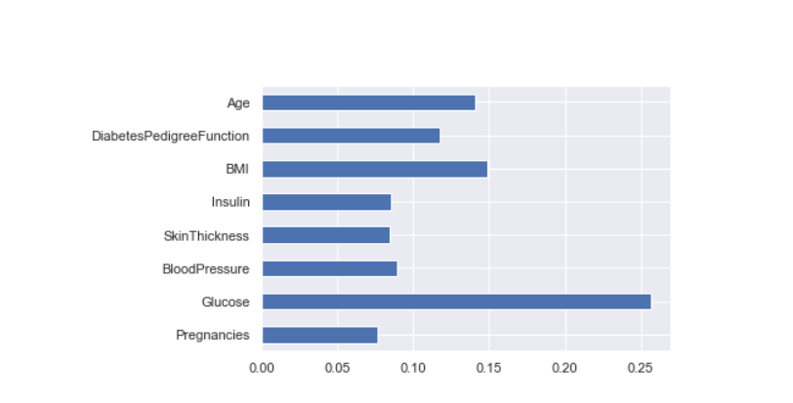

**Saving model Random Forest**

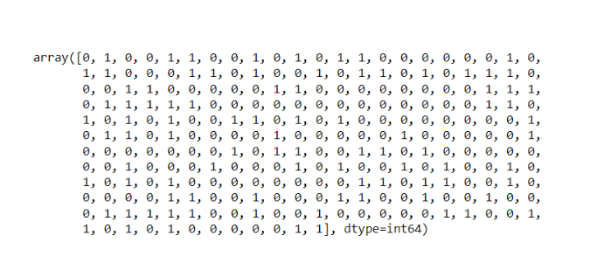

**References**

1. Aljumah, A.A., Ahamad, M.G., Siddiqui, M.K., 2013. Application of data mining: Diabetes health care in young and old patients. Journal of King Saud University - Computer and Information Sciences 25, 127–136. doi:10.1016/j.jksuci.2012.10.003.
2. Arora, R., Suman, 2012. Comparative Analysis of Classification Algorithms on Different Datasets using WEKA. International Journal of Computer Applications 54, 21–25. doi:10.5120/8626-2492.
3. Benbelkacem S, Atmani B. Random forests for diabetes diagnosis. International Conference on Computer and Information Sciences. IEEE; 2019.
4. Han Wu, Shengqi Yang, Zhangqin Huang, Jian He and Xiaoyi Wang, ”Type 2 diabetes mellitus prediction model based on data mining”, Elsevier Informatics in Medicine, vol. 10, pp. 100-107, 2018.
5. Kavakiotisab I, Tsave O, Salifoglou A, Maglaveras N, Vlahavasa I, Chouvarda I. Machine learning and data mining methods in diabetes research. Computational and Structural Biotechnology Journal. 2017; 15: 104- 16.
6. Jia M, Tian F. Readmission prediction of diabetic based on convolutional neural networks. International Conference on Computer and Communications. IEEE; 2019.
7. M Sabibullah, V Shanmugasundaram and Priya K Raja, ”Diabetes Patient’s Risk through Soft Computing Model”, International Journal of Emerging Trends Technology in Computer Science, vol. 2, no. 6, 2013.
8. Pujianto U, Setiawan AL, Rosyid HA, Salah AMM. Comparison of naïve Bayes algorithm and decision tree C4. 5 for hospital readmission diabetes patients using hba1c measurement. Knowledge Engineering and Data Science. 2019; 2(2).
9. Rani, A. S., & Jyothi, S. (2016, March). Performance analysis of classification algorithms under different datasets. In Computing for Sustainable Global Development (INDIACom), 2016 3rd International Conference on (pp. 1584- 1589). IEEE.
10. Sharief, A.A., Sheta, A., 2014. Developing a Mathematical Model to Detect Diabetes Using Multigene Genetic Programming. International Journal of Advanced Research in Artificial Intelligence (IJARAI) 3, 54–59.
11. Sun YL, Zhang DL. Machine learning techniques for screening and diagnosis of diabetes: A survey. Tehnički Vjesnik. 2019; 26(3): 872-80.
12. M Sabibullah, V Shanmugasundaram and Priya K Raja, ”Diabetes Patient’s Risk through Soft Computing Model”, International Journal of Emerging Trends Technology in Computer Science, vol. 2, no. 6, 2013.
13. Warke M, Kumar V, Tarale S, Galgat P, Chaudhari D. Diabetes diagnosis using machine learning algorithms. International Research Journal of Engineering and Technology. 2019; 6(3): 1470-6.
14. <https://www.kaggle.com/datasets/uciml/pima-indians-diabetes-database.>
15. <https://www.researchgate.net/publication/350745659_Diabetes_Diagnosis_Using_Machine_Learning.>
16. <https://www.ijert.org/diabetes-prediction-using-machine-learning-techniques.>

**PLAGIRISM REPORT**

